

__________________________________________________________________________

**SCHOOL OF SCIENCE AND TECHNOLOGY**

**COURSEWORK FOR THE**

**BSC (HONS) INFORMATION SYSTEMS; YEAR 1**

**BSC (HONS) INFORMATION TECHNOLOGY; YEAR 1**

**BSC (HONS) COMPUTER SCIENCE; YEAR 1**

**BSC (HONS) INFORMATION TECHNOLOGY (COMPUTER NETWORKING AND**

**SECURITY); YEAR 1**

**BSC (HONS) SOFTWARE ENGINEERING; YEAR 1**

**BIS(HONS) IN MOBILE COMPUTING WITH ENTREPRENEURSHIP; YEAR 1**

**ACADEMIC SESSION 2020; SEMESTER 2,3,4**

**DEADLINE: 10 JULY 2020 5PM**

|  |  |  |
| --- | --- | --- |
| **STUDENT NAME** | **:** | **1. Brandon Chen Wai Hong (18006684)** |
| **AND ID** |  | **2. Alexander Chua Chong Sein (17037375)** |
|  |  | **3. Sharveendra Pushpanathan (17104902)** |
|  |  |  |

**IMPORTANT**

The University requires students to adhere to submission deadlines for any form of assessment. Penalties are applied in relation to unauthorized late submission of work.

* Coursework submitted after the deadline but within 1 week will be considered as late submission.
* Work handed in following the extension of 1 week after the original deadline will be regarded as a non-submission and marked zero.

**Lecturer’s Remark** (Use additional sheet if required)

I................................... (Name) .........................std. ID received the assignment and read the

comments....................................... (Signature/date)

**Academic Honesty Acknowledgement**

“I **Brandon Chen Wai Hong, Alexander Chua Chong Sein, Sharveendra Pushpanathan** (student name). verify that this paper contains entirely my own work.  I have not consulted with any outside person or materials other than what was specified (an interviewee, for example) in the assignment or the syllabus requirements.  Further, I have not copied or inadvertently copied ideas, sentences, or paragraphs from another student.  I realize the penalties *(refer to the student handbook and undergraduate programme)* for any kind of copying or collaboration on any assignment.”

......brandon....., ....alex......, ...sharveendra... (Student’s signature / Date)

Group Number: 27

Team Members:

|  |  |  |  |
| --- | --- | --- | --- |
| No. | Name | Student ID | Who upload to eLearn(tick) |
| 1 | Brandon Chen Wai Hong | 18006684 | ✅ |
| 2 | Alexander Chua Chong Sein | 17037375 |  |
| 3 | Sharveendra Pushpanathan | 17104902 |  |

**Class Diagram**

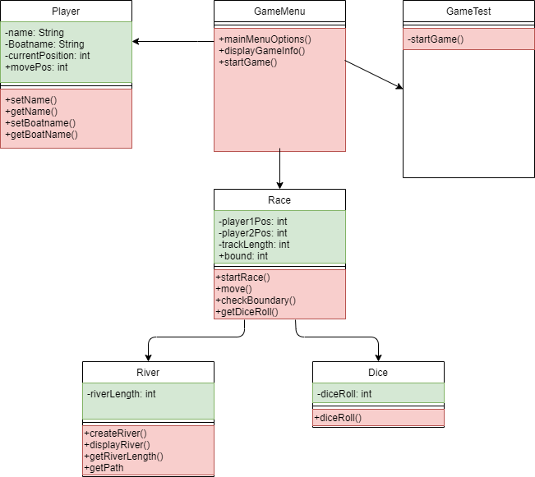

**Question:**

Explain with a short paragraph what can you do or how will you design the program with the flexibility to allow future expansion of adding more types of water vehicles to the game e.g. cruise ships, battleships, canoes, ferries, yachts and etc.

We will first create another class, Boat, which will have the attributes of boats, like type, with individual features like speed or actions. Players will then be allowed to choose from these boats to be played during battle. Features of boat such as speed, for example boats can go extra steps for each dice roll, or action which allows boats to sabotage others. This can lead to more creativity in plays, and not as repetitive as just rolling the dice.